LOW FIDELITY EQUIPMENT TO CREATE HIGH FIDELITY “IN SITU” SIMULATION SOLUTIONS
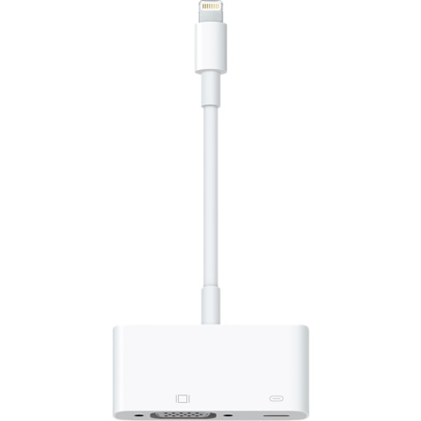
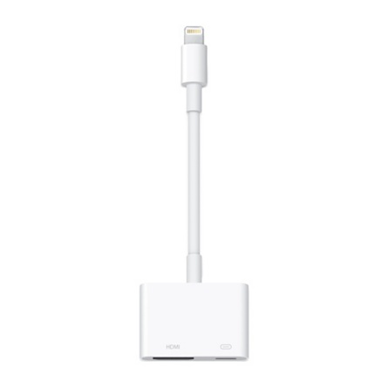
Apple Lightning to VGA - £49.00 To connect Apple iPad ( video or Sim Monitor ) to VGA Cable

Apple Lightning to VGA - £49.00 To connect Apple iPad ( video or Sim Monitor ) to HDMICable

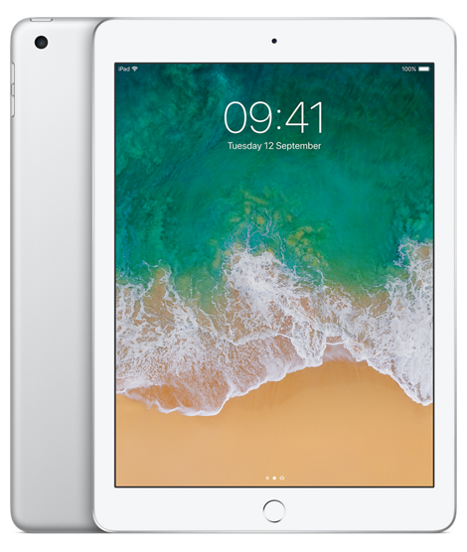
iPad mini From £399 for 32GB ( more than enough storage required to perform the function of either camera or monitor (SimMon)

SimMon - £14 App store. Use any pair of iOS devices (iPad / iPhone) as a simple remote controlled 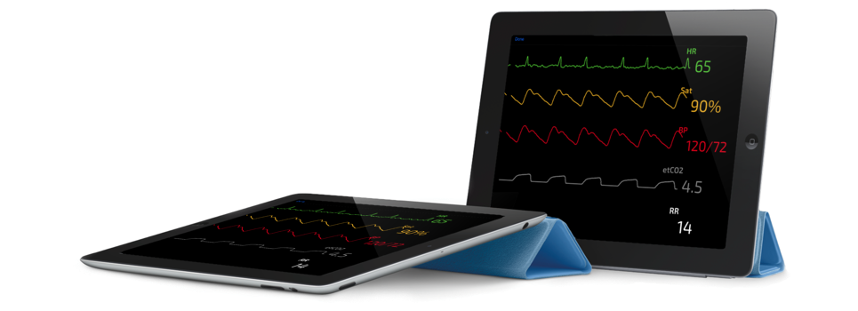simulated patient monitor. Change the blood pressure, oxygen saturation or heart rate with a touch. Simple setup. Easy operation. Low cost.

Below is priced in the UK from RS Components Ltd. Birchington Road, Corby, Northants, NN17 9RS, UK
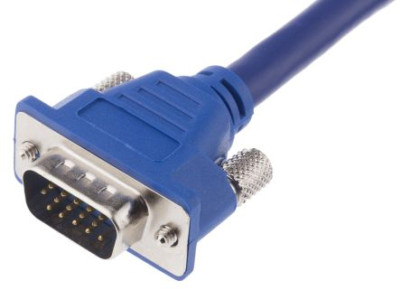
- VGA CABLE – 5m Clever Little Box Blue VGA Monitor Cable Assembly, Male VGA to Male VGA £13.00each
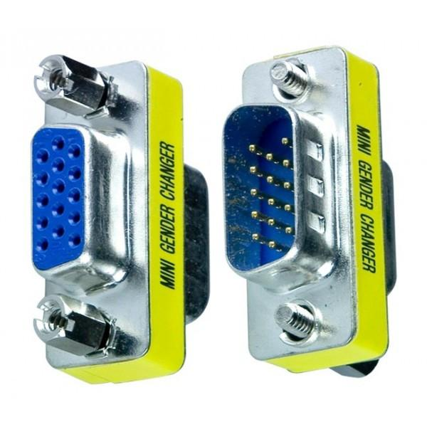
- VGA Female to Female / Male to Male Coupler – To allow you to extend your length of VGA Cable as far as you like. £2.50 each

- Sennheiser Wireless Microphone and receiver set £499.00 -
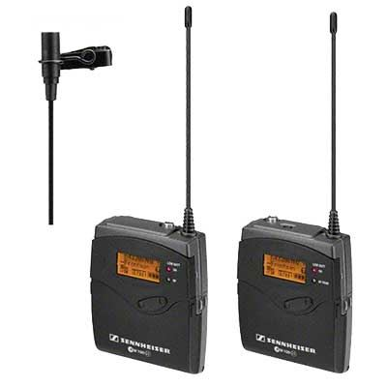
User-friendly and designed for portable wireless operation, the Sennheiser EW-112P G3 GB Portable Wireless Microphone System is suitable for presentations, live broadcast and reporting on the move. The system is made up of 1x EK-100 G3 diversity receiver, 1x SK-100 G3 bodypack transmitter, 1x ME-2 clip-on microphone (omni-directional lapel), 1x CL-1 jack cable, 1x CL-100 XLR cable, 1x CA-2 camera adaptor, 4x AA batteries and operating instructions

- Saramonic UwMic9 UHF Wireless Mic package TX9+TX9+RX9 £349.00
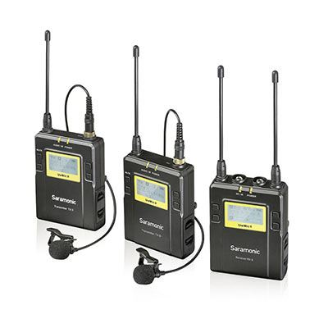
The Saramonic UWMIC9 UHF Wireless Mic Package contains 2 TX9 units, as well as an RX9. The package provides broadcast quality, interruption free wireless audio in a portable, compact, low-cost package. The RX9 is a camera mountable wireless receiver, while the TX9s are body-worn wireless transmitters with 2 clip-on lavalier microphones.
- £ 135 From Amazon - BOYA BY-UM48C Professional UHF Omni-Directional Wireless Lavalier Microphone System for Canon EOS 5D3 5D4 Nikon D500 D750 D810 Sony A9 Panasonic DSLR Camera Camcorder GoPro Hero 4 3 3+
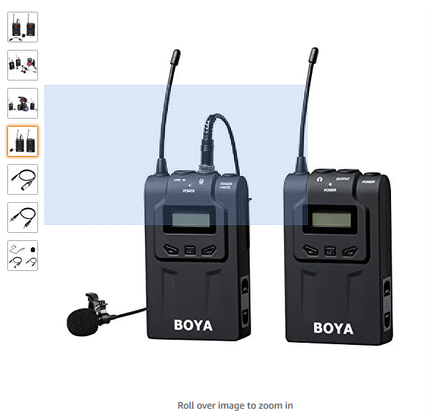

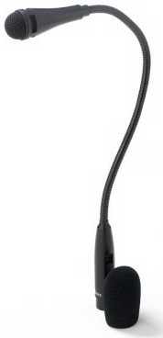
- 3-pin XLR connector Directional Microphone ( for capturing room sound ) with the above mic packs £24.00

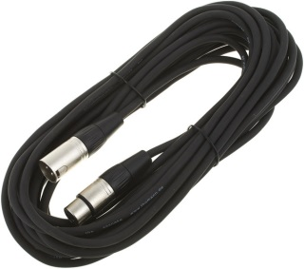
- 3 pin XLR cable to connect to the mic receiver £5.00

- 3.5mm stereo audio cable (any short length) £5
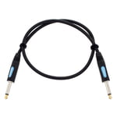

- Fake Blood (Any fake blood you can purchase in your country) However Food colouring or fake blood that stains should be avoided at all cost. If when using in the clinical environment it will stain equipment, floors, beds and people and clothes.

- Silicon to make fake skin or bits of old manikin to be used to place over simulators or real people – Search Pintrest to find out more

