Completed in 2011 GAPS is our 2nd purpose built clinical skills and simulation department, benefiting from over 30 years combined team experience to design a simulation centre incorporating two high fidelity simulation suites. Ethernet protocol audio-visual recording capability and utilising a conjoined control room to allow coordination of attainment of learning outcomes during simultaneous simulation events.
Each room is easily converted to be used according to the learning objectives of each course and is equipped with the following:
50 “ Plasma / Data Projection, Computer with internet, wireless access to internet, Scotia Medical Observation Training Systems (IP Cameras) with record and playback facility, telephone (internal & external access), flip charts, air-conditioning and a large red digital network clock for time-lining the video footage. GAPS use a wireless microphone system to allow capture of any or all conversations made either face to face or via telephone with the ability to play back in the reflective debrief sessions.

GAPS SITE PLAN – 4th Floor Hunter Wing
St.George’s University of London

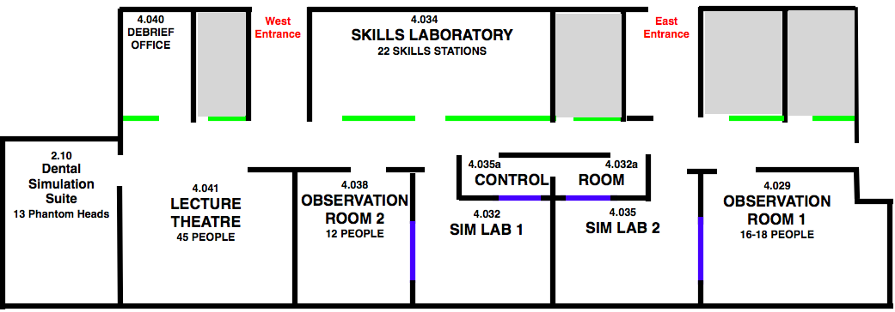

OUTLINE OF FACILITIES AVAILABLE
Simulation Labs 1 & 2

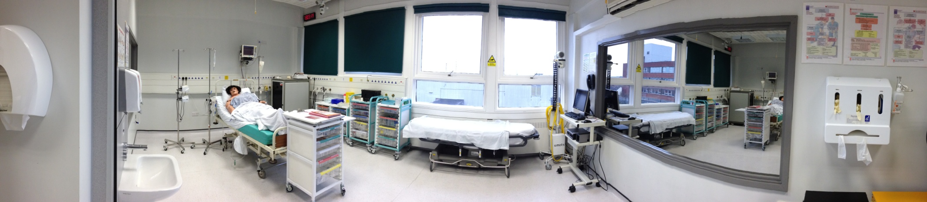

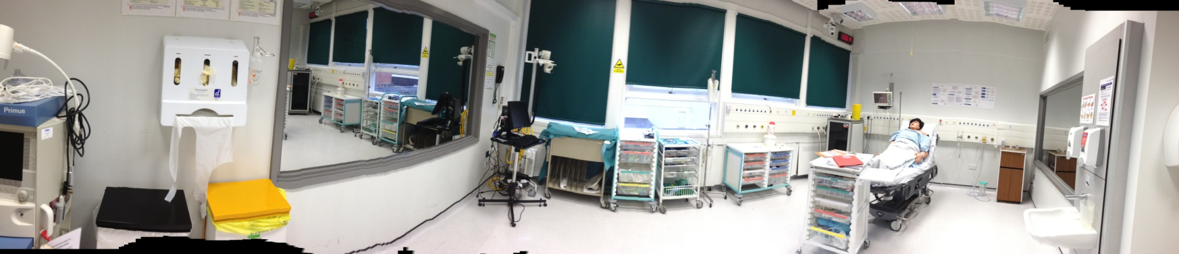

Two dedicated High Fidelity Simulation suites which allow the flexibility to run simulation scenarios in the ward, the trauma bay, ITU or the operating theatre.
Complete with a CEA – METI High Fidelity Human Patient Simulator (HPS) mannequins in each lab we utilise standard Trust monitoring devices to monitor patient vital signs. This capability allows us to train using the exact same medical devices that staff use in the clinical environment. Each clinical environment has been designed with the same clinical facia found in real ward / ITU settings. Real oxygen, medical air, nitrous oxide and suction are built into the facia.

We can incorporate ITU ventilators, anaesthetic machines and advanced cardiac output monitoring devices to measure fluid optimisation response like the LIDCO cardiac output device.

Observation Rooms 1 & 2
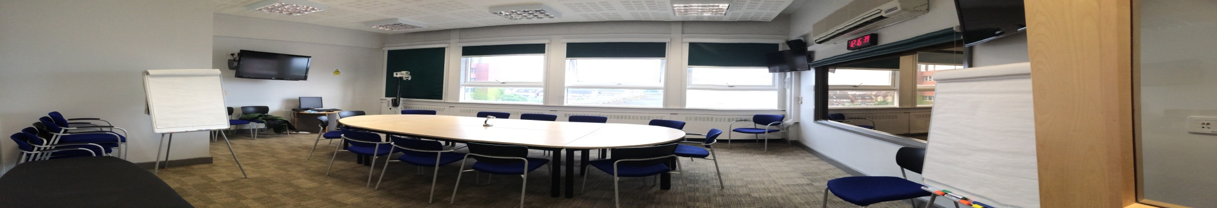

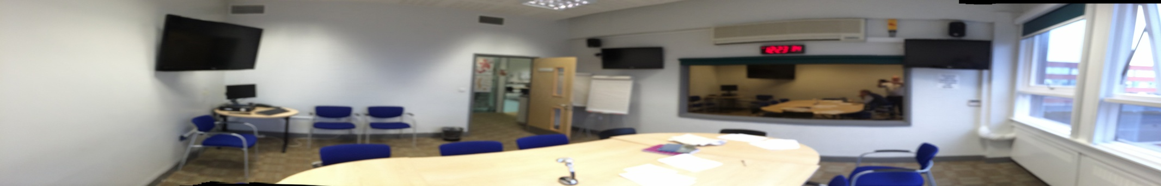
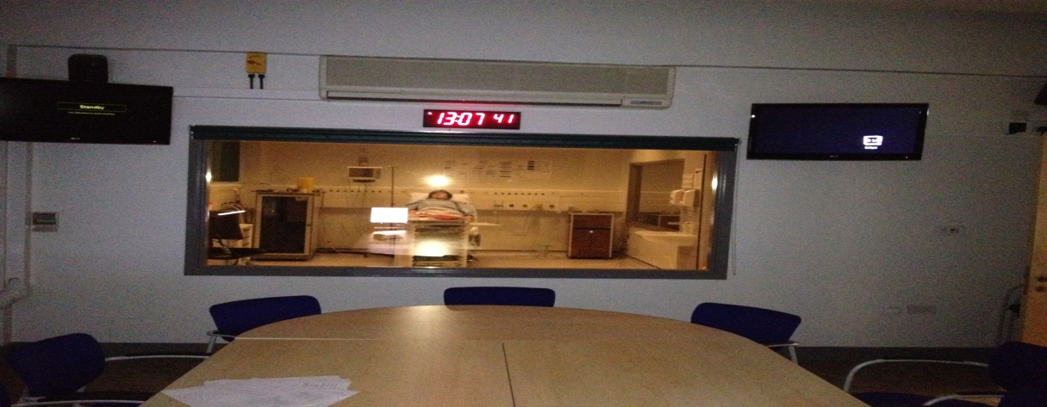

Bespoke observation / facilitation facilities with dedicated overhead monitor clones repeating the patient physiology and patient blood results, x-rays etc. This allows observers to follow the clinical progression of a scenario while reviewing team interactions facilitating peer feedback. Live internet protocol video recording capacity enhancing feedback through the use video playback to identify aspects of performance / practice.
Control Rooms 1 & 2

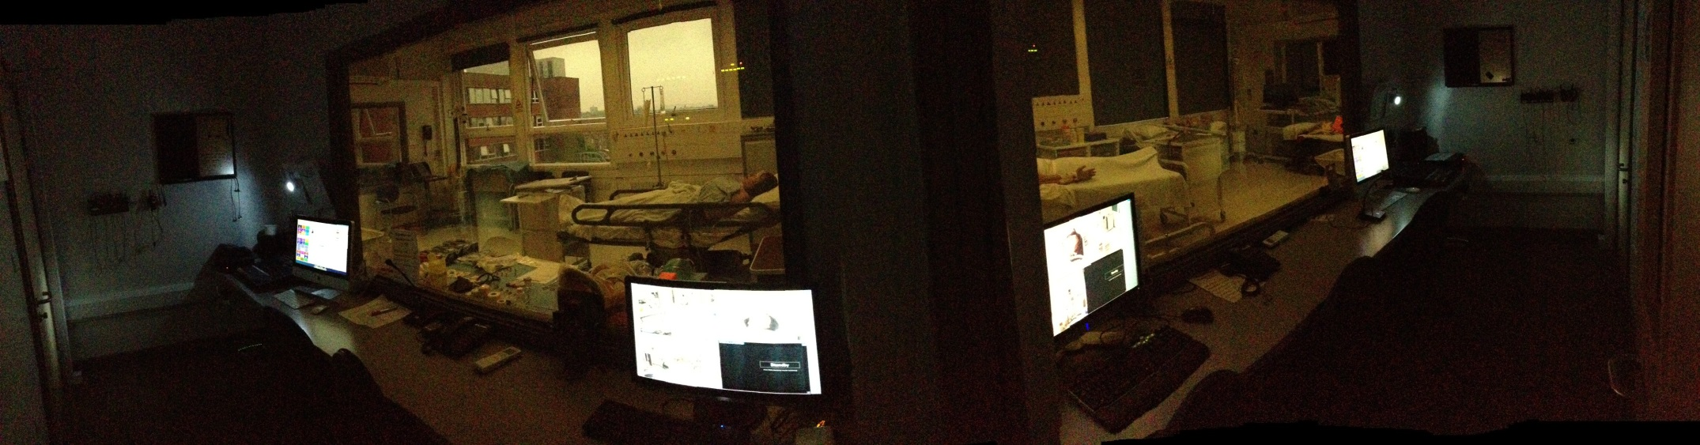
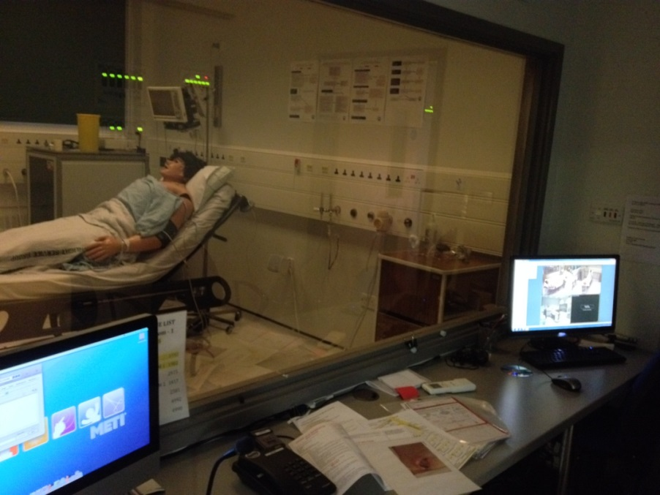
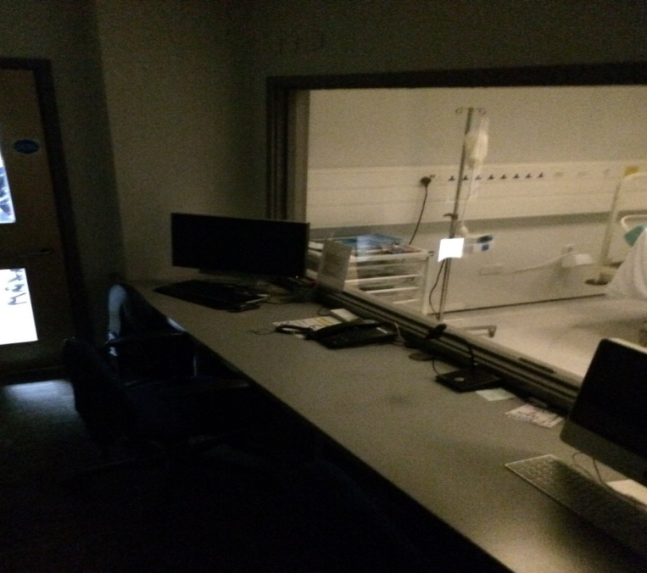

Scenarios are run and Mannequins are programmed from here. Faculty can observe practice through the one-way mirror whilst controlling the scenario progression as well as making timeline notes for giving feedback.

Lecture Theatre & small debrief / breakout rooms to the left

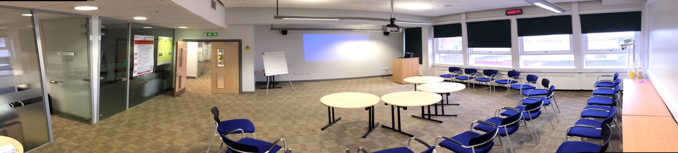

Comfortably seating 45 people at any one time with full AV presentation capabilities.

The breakout room to left is used for small group debriefing, 1 to 1 conversations as well as telephone referrals etc. Again each room has the capacity to record image and sound.

Dental Simulation Suite

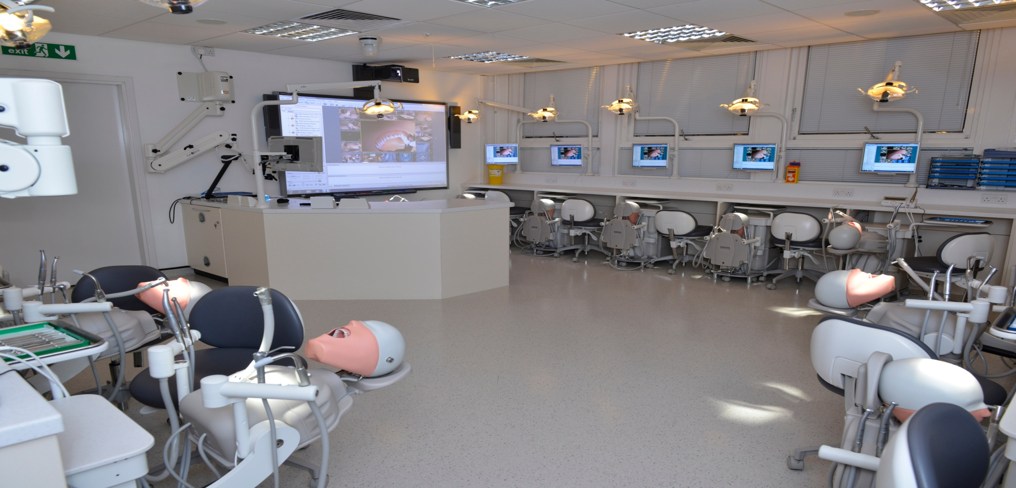

A state of the art Dental simulation suite, with 13 dental training phantom heads and a projected instructor station. Equipped with 4 microscopes for advanced dental surgical procedure training.

This room is also used as a multi-purpose team training feedback environment whereby teams can analyse video footage of both individual and team performance using SMART board technology to further highlight specific issues and reference them for future feedback.

Surgical Skills Laboratory

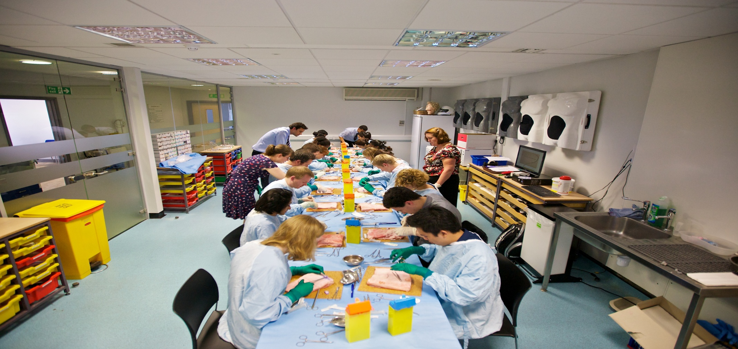

An array of surgical skills are taught in the surgical skills lab. These range from basic surgical skills and suturing to advanced laparoscopic surgical procedure and seconded courses from the Royal College of Surgeons. This room is used as additional teaching space on a number of courses with a 50” plasma screen at each end of the room allowing the room to be divided in two if required.

