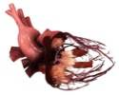
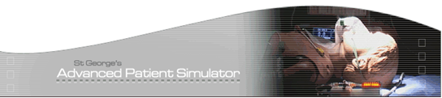

St George's Hospital TOE Sim Course
Introduction to TOE
5th-6th May 2016

Course overview
The St George's Hospital TOE Sim Course is a 2 day course aimed at novices in transoesophageal echocardiography. Lectures covering the principles of transoesophageal echocardiography are supplemented by hands on experience using HeartWorks TOE simulators. All attendees are also enrolled for HeartWorks e-learning to support their TOE training.

The course content includes
- basic physics of ultrasound image acquisition
- practical aspects of probe and ultrasound plane manipulation
- acquisition of conventional imaging planes
- focussed examination of cardiac valves and chambers

Course venue
Simulation and Skills Centre
4th Floor Hunter Wing
Medical School
St. George's Hospital
London SW17 ORE

The nearest underground station is Tooting Broadway (Northern line). There is limited visitors' parking, which is expensive, so attendees are advised to use public transport.

Course faculty
The faculty comprises practising clinicians from St. George's Hospital in London. The course is organised by the hospital’s anaesthetic department, which has an established reputation in TOE training.

Course fee
The course fee for External candidates is £350, for Internal St George’s candidates is £100 which includes registration on the HeartWorks e-learning TOE course as well as breakfast, lunch, tea and coffee.

How to apply
Please complete and return the attached registration form, along with payment, to Robert Colson at the address below. A place on the course will be confirmed by email.

Contact
For further information please contact Robert Colson
Clinical Skills and Simulation Co-ordinator
St. George's Advanced Patient Simulator Centre
4th floor Hunter Wing
St. George's Hospital
Cranmer Terrace
London SW17 0RE
Tel No: 0208 725 3574
email: robert.colson@stgeorges.nhs.uk


ST. GEORGE'S HOSPITAL TOE SIM COURSE
Booking form

Course date | 5th-6th May 2016
Name
Address
Email address
Hospital
Specialty and grade
Previous TOE experience | none / minimal / competent at basics / experienced
Special dietary requirements
The course fee is £350 external staff and £100 for St George’s staff. Please make cheques out to St George’s University Hospital NHS Foundation Trust, and post it with your completed registration form to the address below. You can also pay by Debit / Credit card.

Robert Colson
Clinical Skills and Simulation Co-ordinator
St. George's Advanced Patient Simulator Centre
4th floor Hunter Wing
St. George's Hospital
Cranmer Terrace
London SW17 0RE
Tel No: 0208 725 3574

A place on the course will be confirmed by email.
If you have any queries please email robert.colson@stgeorges.nhs.uk

